*Please Complete the following paper work & Return it to Katie Lancaster at the School or Parish Office between now and No later than Jan 7th.
Holy Family Catholic Church

Confirmation Registration 2018

Dear Parents,

Hello my name is Katie Lancaster; I am the Youth Minister here at Holy Family & will be preparing your teen this year for the Sacrament of Confirmation!

First date to remember- Sun, Jan 7th 2018- Parents & Students will be meeting together from 10am-11am in the school Library for a Pre-Confirmation Intro.

All Completed Paperwork is Due no later than Jan 7th!!!
At the meeting you will be given books, schedule, info on what to expect, what is required & an overall look at this coming year. If you have any questions please feel free to contact me.

Please Note: Confirmation Schedule and all the following paper work can be found on Our Parish Website: Holyfamilystpete.com (under the tab “Sacraments”) or Hfym.info (Under the tab “Confirmation”)

I look forward to meeting you & your teen!
Until then God Bless,

Katie Lancaster
Email: Katiehfym@gmail.com
Phone: 727-526-5783 ext28
Website: Holyfamilystpete.com
Youth Ministry Events & info- HFYM.INFO

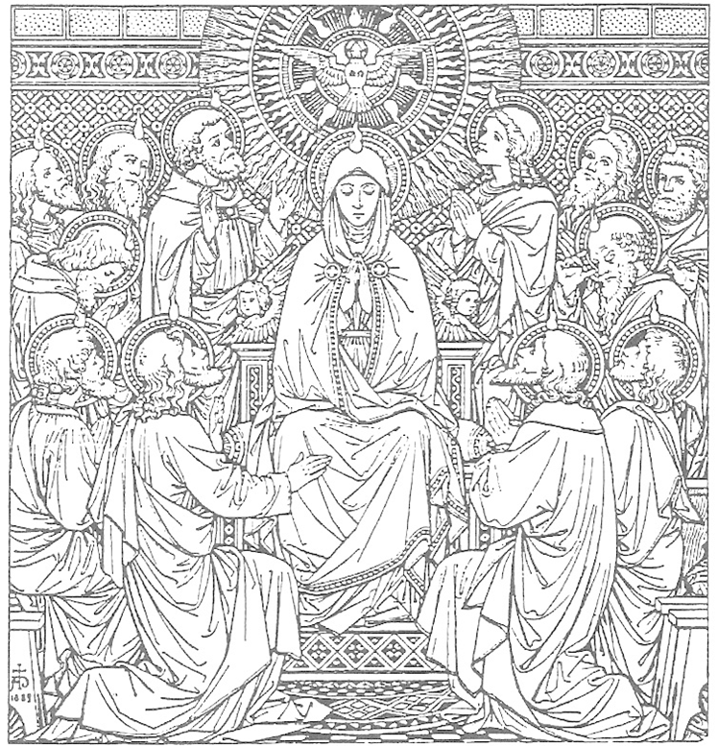

Note to Parents: Your participation in your son or daughter’s Confirmation preparation is vital to a successful reception of the sacrament. Ultimately “Living” the faith [that is well-formed] is far more important, than “learning” the faith.
- Be open to your child’s questions.
- Let him see you attend Mass every week and go to confession
- Talk about why you are still Catholic and believe all the Church’s teachings.
- Explain to her why you believe that Christ is truly present in the Eucharist
- Pray the blessing every night before dinner (+ other prayers) and let your child know that you live the faith.
- Let your children see you read about the faith (Scripture, books on saints or other spiritual reading)

It’s a struggle to help your child remain a believing Catholic for the rest of their lives. Confirmation, with the help of the Holy Spirit, is the beginning and a needed help in this eternal struggle.
Confirmation Schedule for Class of 2018
Requirements: All Confirmation Classes are Mandatory. If for any reason a student fails to attend a session the student is required to notify the teacher and make up the work by the following session.
Sun, Aug 20th- Registration Open
After all the Sunday Masses in School Dining Hall- Pick up Confirmation Packet with all info/paper work that must be COMPLETELY filled out and turned in by- JAN 7th
Sun, Jan 7th- Pre-Confirmation Intro – All paper work Due!!
Parents & Students Meeting together/ 10am-11am – school Library
Sun, Jan 21st- Confirmation Session #1- “The Power of the HS”
10am-12pm – school Library
Sun, Feb 4th- Confirmation Session # 2- “The Holy Spirit in Scripture”
Sponsors & Students Meeting: 10-10:45am in school Library (Sponsors should expect to get out at 11am)
Students: 10:45am-12pm – school Library *Be sure to have chosen your Patron Saint & are working on your Saint Project!
Fri, Feb 9th - Saints Project Drop Off! Anytime between 3pm-5:30pm Students must drop
off/set up their projects in Diffley Hall in preparations for the Saints fair.
(Option Morning drop off b4 school: Diffley hall will be unlocked in the morning for parents who would like to walk their child over to drop their project off at Diffley hall. Please place project on table labeled Drop Off. No adult will be present at this time. Students: Please stop by after school if you need to set it up your presentation.)

Sun, Feb 11th Saints Fair! @Diffley Hall/ after 9am Mass come promptly to Diffley hall, stand by your project and prepare to present it to all those who visit the Saints Fair!
Sun, Mar 4th Confirmation Session # 3- “Moved to Mission”
10am-12pm – school Library

Sun, Mar 11th Confirmation Session # 4- “The Gifts & Fruits of the Holy Spirit”
10am-12pm – School Library (Letters of request due to Fr. Morley)

Sat, Mar 17th Confirmation Retreat
@ Sacred Heart-Pinellas Park / Time:11am-6pm– Retreat is Mandatory.
Sun, Mar 25th Confirmation Session #5 - “The Rite of Confirmation”
10am-12pm – School Library

Wed April 4th- Confirmation Practice
Meet in church /Time: TBA -Come Wearing your Red Confirmation T-Shirts!

Sun April 8th - Sacrament of Confirmation -11am Mass
*Stay for Group Picture immediately afterward in front of Alter! All welcome to the Confirmation Reception in Diffley Hall. The Students Confirmation certificates & gift will be at the reception.
Go make Disciples of all Nations!

PAPERWORK CHECKLIST
ALL Below must be completed no later than January 7th!

- _______ Registration Paperwork is completely filled out
- _______HF Church has a Copy of Baptismal Certificate
- _______I Have paid the $60.00 for Registration fee to the Church

- _______I Have Completely Filled out my child’s Medical form and have gotten it Notarized by a notary. (Terry at the Parish front office is a Notary)

- ______I Have Completely filled out my child’s Media form.
- _______My child has Read and understands the role of a Confirmation Sponsor and has chosen their Confirmation Sponsor.
- _______ I have the Sponsor Certificate paperwork filled out and sent out to the Sponsors Parish for their Pastor to approve sign and seal.
- _______If Needed I filled out a Proxy Form (Sponsor will not be able to be present)
- _______I Have Signed the Confirmation Retreat Permission Form

- ______I Remembered to mark my calendar for Sun, Jan 7th 2018 for the Pre-Confirmation Intro From 10am-11am in the school Library.

- _______ I know that the Last day to turn in All Paperwork in is JANUARY 7th!!!
Registration for the Sacrament of Confirmation 2018

Candidate’s Full Name________________________________________________

Date of Birth____________________ Adult Shirt Size for Confirmation Shirt
Sizes S/M/L/XL = ______
Place of Birth____________________

Date of Baptism___________________
Church of Baptism____________________________
Location of Church (City, State, Country)________________________________________
*A copy of the Baptismal Cert. must be on file in the Faith Formation Office
Was the Child Baptized at a different Parish then Holy Family Parish? ______
If YES= You Must Provide a Copy of the Child’s Baptismal Certificate from that Parish.
Father’s Full Name_________________________________________________
Mother’s first, middle, and maiden Name_________________________________________
Home Address________________________________________________________
City, State, Zip________________________________________________________
Phone number(s)________________________________________________________
E-Mail________________________________________________________________
Parish ID #__________________________________
This can be found on your Parish donation envelopes
Preparation Fee: There is a $ 60.00 sacramental preparation fee to help cover a portion of the costs. This is not included in the registration fee for Sunday morning Faith Formation Sessions.
_____________________________________________________________________
For Office Use:

Bap Cert_______ Sponsor Cert_______ Prep Fee________

Retreat Permission Form______ Notarized Medical Form ______ Media Form_____

Photos ok?_______

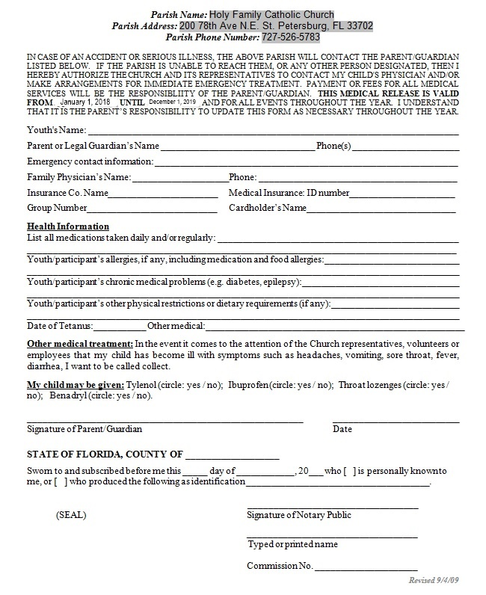

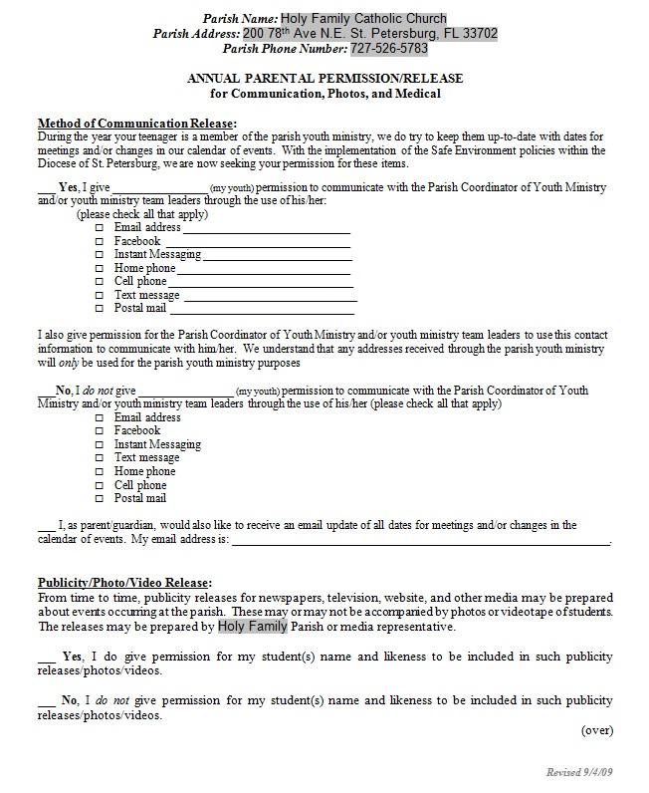

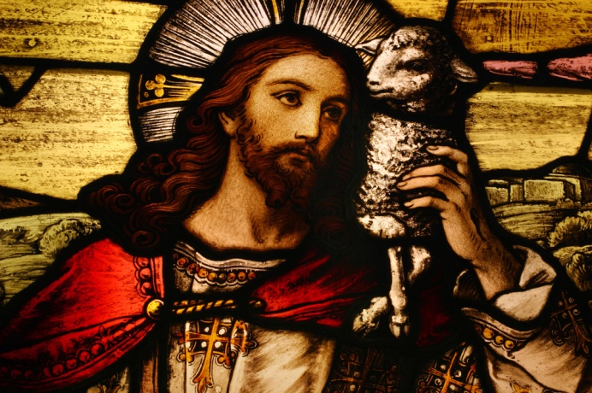
CHOOSING A SPONSOR
All Confirmation candidates must be presented to the Bishop by a qualified sponsor. This sponsor, while chosen by the candidate, must have certain qualities that are spelled out fully in church law.
A Sponsor:
- Must be a Catholic who actively practices the faith and attends Mass weekly.
- Must be at least 16 years old and already confirmed.
- May not be a parent of the candidate.
- If married, the marriage was in a Catholic church or validated by the Catholic Church.
- Need not be the same gender as the candidate.
While not part of the church law, it is strongly encouraged that a candidate selects one of his/her godparents for his/her Confirmation Sponsor. This expresses more clearly, the relationship between Baptism and Confirmation as Sacraments of Initiation and makes the function and responsibility of the Sponsor more effective. However, candidates may choose a different Sponsor for Confirmation.
In addition to the requirements stated above, a sponsor should exemplify these qualities:

- Is the life of this person a testimony of his/her commitment to the Lord and to the Church?
- Is this person physically nearby to be part of the life of the candidate during the preparation process?
- Will this person be willing and eager to guide the candidate as they continue to learn: - To pray in new ways? - To witness? - To recognize the workings of the Holy Spirit? - More about the Catholic faith? - More about their parish and how to participate in parish life? - How to overcome doubts, fear, and temptation through their relationship with God?
- Will this person pray for the candidate regularly?
- Is the candidate able to approach this person with questions they have about their faith and spirituality?
After the candidate has prayerfully chosen a Sponsor, have him/her complete the information sheet found on page 13. This form must be turned in to Katie Lancaster by Jan 7th 2016. This deadline provides the sponsor time to assist the candidate during the course of their preparation for the sacrament.

CONFIRMATION SPONSOR CERTIFICATE
PLEASE RETURN THIS FORM AS SOON AS POSSIBLE TO:
Holy Family Catholic Church Parish Office
200 78th Ave. N.E.
St. Petersburg FL 33702
THIS FORM IS TO BE SIGNED BY THE SPONSOR AND HIS PASTOR.

THE ROLE OF THE CONFIRMATION SPONSOR
Candidates for Confirmation, as for Baptism, fittingly seek the spiritual help of a sponsor. To emphasize the unity of the two sacraments, it is appropriate that this be one of the baptismal godparents. Although one of the Confirmation candidate’s godparents is the ideal, this is not the only choice (CCC 1311).
Like the godparents chosen at Baptism, sponsors “must be firm believers, able and ready to help (the Confirmed) on the road of Christian life. Their task is a truly ecclesial function….bearing some responsibility for the development and safeguarding of the grace given at Baptism” (CCC 1255). Like parents and godparents, they share in the responsibility for the salvation of the young soul entrusted to them.
Because our life on earth is “a pilgrimage to the Father which takes place primarily in the heart” (Pope John Paul II, The Trinity’s Embrace), the sponsor should be a Catholic who loves and lives his or her faith and continues to grow in the knowledge of the Catholic faith. This is evident in a person who spends time in daily prayer and frequent encounters with Jesus in the Sacraments of Penance and Holy Eucharist. Consequently, the sponsor’s heart reflects the tender and affectionate love of the hearts of Jesus and Mary and the gifts of the Holy Spirit, providing a living example of joyful Christian life.

THIS IS TO CERTIFY THAT I

_________________________________
Sponsor’s name
A REGISTERED MEMBER OF ________________________________IN______________________
Parish name City, State
ACCEPT THE INVITATION TO BE THE SPONSOR AT THE CONFIRMATION OF

____________________________________
Candidate’s name
In accepting this responsibility, I truthfully state all the following:
- I am at least 16 years of age.
- I have received the Sacraments of Baptism, Eucharist and Confirmation in the Catholic Church.
- I am not married outside the Catholic Church or living contrary to Church teachings.
- I attend Mass regularly on Sundays and Holy Days of Obligation and receive the Sacraments of the Holy Eucharist and Penance regularly.
- I am not a parent of the Confirmation candidate. I understand and accept the responsibility which I undertake as a Sponsor and I promise to be a support and example that reflects the spirit and teaching of the Roman Catholic Church. I am prepared to assist the Candidate by my support, encouragement and prayer.

________________________________
Sponsor’s Signature
PRIEST’S CERTIFICATION
This is to certify that the above is a registered member of this parish in good standing and, to the best of my knowledge, is capable of assuming the duties and responsibilities of the role of Sponsor.

________________________________
Priest’s Signature
________________________________
PARISH SEAL (MUST BE PRESENT) Parish
________________________________
Date
SPONSOR &PROXY FORM
[Form used only if a Confirmation Proxy is needed in place of the Sponsor]

Please Print or Type All Information.
Turn in this form as soon as possible.

Candidate’s Name: ____________________________________________________ Date: ______________

SPONSOR INFORMATION

Sponsor’s Name _________________________________________ Relationship _____________________

Sponsor’s Address________________________________________ Phone __________________________

*Even if your sponsor is a member of St. John the Baptist parish, have him/her complete and submit the
Confirmation Sponsor Form, including the priest’s certification.

PROXY INFORMATION
(If your Sponsor will not be present at the Confirmation)

Proxy’s Name ___________________________________________ Relationship _____________________

Proxy’s Address __________________________________________ Phone __________________________

In order to accept this responsibility, your Confirmation proxy needs.
- to be at least 16 years of age.
- to have received the Sacraments of Baptism, Eucharist and Confirmation in the
Catholic Church.
- not to have married outside the Catholic Church or is currently cohabitating, i.e. “living in sin”.
- to attend Mass regularly on Sundays and Holy Days of Obligation and receive the
Sacraments of the Holy Eucharist and Penance regularly.

